CHAP. 10 CASE STUDY 1: UNIX, LINUX, AND ANDROID

PROBLEMS
1. Explain how writing UNIX in C made it easier to port it to new machines.
>>> The development of Unix in the C language made it uniquely portable and improvable. The first version of Unix was written in the low-level PDP-7 assembler language. Soon after, a language called TMG was created for the PDP-7 by R. M. McClure.
2. The POSIX interface defines a set of library procedures. Explain why POSIX standardizes library procedures instead of the system-call interface.
>>> System call interface is tightly coupled to the OS kernel. Standardizing the system call interface would have put severe restrictions (less flexibility) on the design of the OS kernel. It would also make UNIX less portable.
3. Linux depends on gcc compiler to be ported to new architectures. Describe one advantage and one disadvantage of this dependency.
>>> This allows Linux to use special capabilities (like language extensions) of the gcc compiler that range from providing shortcuts and simplifications to providing the compiler with hints for optimization. The main disadvantage is that there are other popular, feature-rich C compilers like LLVM that cannot be used to compile Linux. If at some future time LLVM or some other compiler becomes better than gcc in all ways, Linux will not be able to use it. This could become a serious problem.
4. A directory contains the following files:
aardvark | ferret | koala | porpoise | unicorn
bonefish | grunion | llama | quacker | vicuna
capybara | hyena | marmot | rabbit | weasel
dingo | ibex | nuthatch | seahorse | yak
emu | jellyfish | ostrich | tuna | zebu
Which files will be listed by the command ls [abc]*e*?
>>> First, be aware that, while many other commands use regular expressions, ls uses globs. Let's break down what the glob [abc]*e*? matches:
- [abc] matches one character chosen from set a, b ,or c.
- * matches any number of any character
- e matches e.
- * matches any number of any character.
- ? matches any one character.
For example, consider a directory with these files:
$ ls a1w2e3z41 ae1 af1 de1
The matches among these to the glob are:
$ ls [abc]*e*? a1w2e3z41 ae1

5. What does the following Linux shell pipeline do?
grep nd xyz | wc –l
>>> To search for a string in a file, pass the search term and filename to the command line:
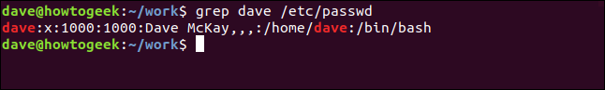
Matching lines are displayed. In this case, it is a single line. Matching text is highlighted. This is because on most distributions grepthe alias is:
alias grep='grep --colour=auto'
See results with multiple matching lines. We will look for the word “Average” in the application log file. Because we can't remember whether the word is in lowercase in the log file, we'll use the -i (ignoring case) option:
grep -i Average geek-1.log
All matching lines are displayed, with matching text highlighted in each line.
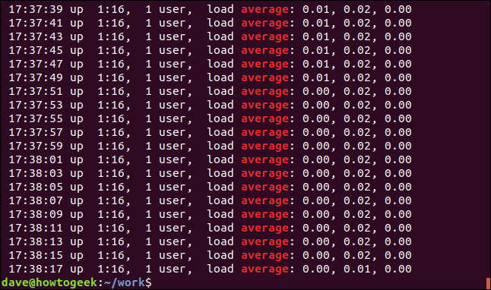
We can display mismatched lines using the -v (invert match) option.
grep -v Mem geek-1.log
There are no highlights as these are mismatched lines.
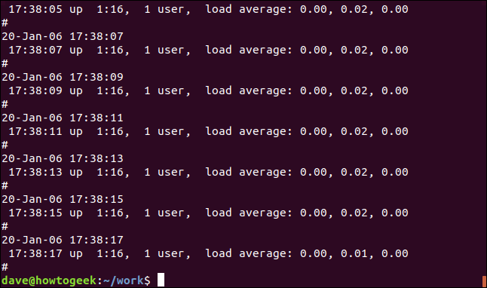
We can cause grepcomplete silence. The result is passed to the shell as a return value from grep. A result of 0 means the string was found and a result of one means it didn't have to be found. We can check the return code using $?special parameters:
grep -q average geek-1.log
echo $?
grep -q howtogeek geek-1.log
echo $?
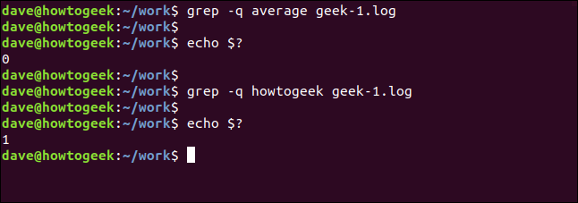

Recursive search with grep
To search through nested directories and subdirectories, use the -r (recursive) option. Note that you do not provide the filename on the command line, you must provide the path. Here we are looking in the current directory “.” and any subdirectories:
grep -r -i memfree .
The output includes the directory and filename of each matched line.
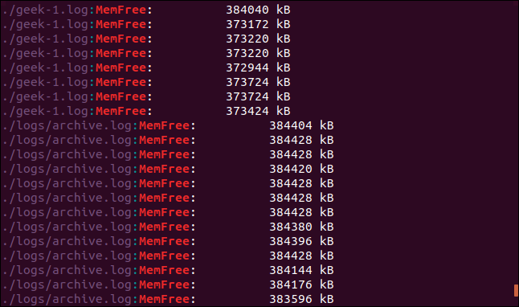
We can grep follow symlinks using the -R(recursive dereference) option. We have a symlink in this directory, called logs-folder. It just comes /home/dave/logs.
ls -l logs-folder
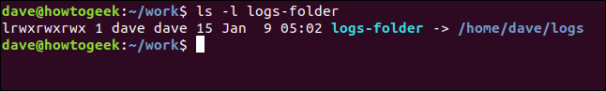
Let's repeat our last search with the -R(recursive dereference) option:
grep -R -i memfree .
The symbolic link is followed and the directory it points to is searched by greptoo.
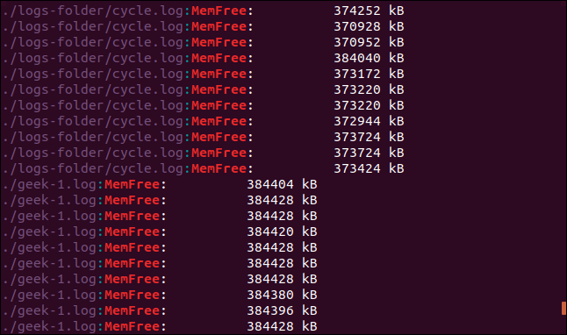

Full word search
By default, grepwill match a line if the search target appears anywhere in that line, including inside another string. Look at this example. We will search for the word “free”.
grep -i free geek-1.log
The result is lines with the string "free", but they are not separate words. They are part of the “MemFree” series.
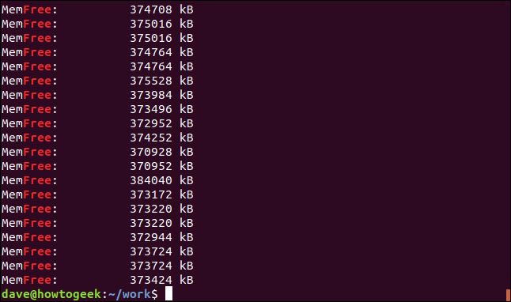
Forcing grepto match only distinct “words”, use the -w(from regexp) option.
grep -w -i free geek-1.log
echo $?
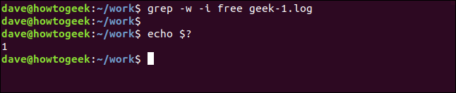
There were no results this time because the search term “free” did not appear in the file as a separate word.

Use Multiple Search Phrases
The -E(extended regexp) option allows you to search for multiple words. ( -EOptional alternatives are deprecated egrepversions of grep.)
This command searches for two search terms, “medium” and “memfree”.
grep -E -w -i "average|memfree" geek-1.log
All matching lines are displayed for each search term.
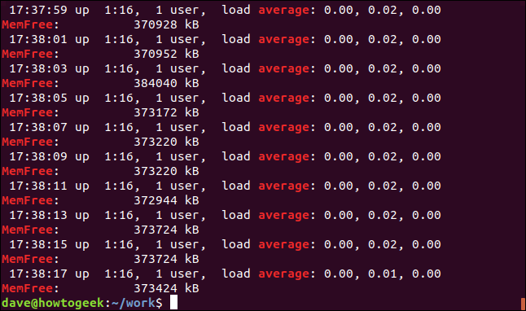
You can also search for phrases that don't have to be whole words, but they can also be whole words.
The -eoptional (templates) allows you to use multiple search terms on the command line. We are using the regular expression brackets feature to create a search pattern. It says grepto match any character enclosed in brackets “[]. ” This means grepwill match “kB” or “KB” when it searches.
Both strings are matched and, in fact, some lines contain both.
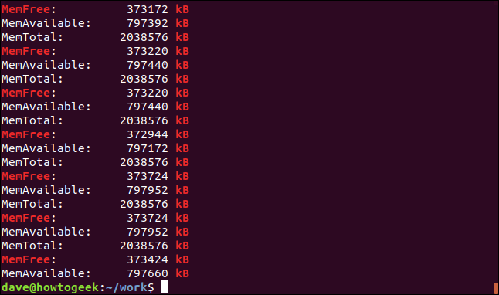

Exact match of lines
The -x(regexp lines) will only match lines where the entire line matches the search term. Let's look for date and time stamps that we know appear only once in the log file:
grep -x "20-Jan--06 15:24:35" geek-1.log
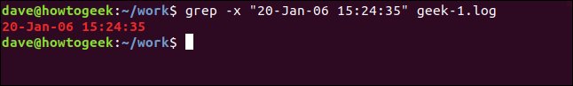
The only matching line is found and displayed.
The opposite of that is showing only lines that don't match. This can be useful when you are looking at configuration files. Comments are great, but sometimes it's hard to figure out the actual settings among them. Here is /etc/sudoersthe file:
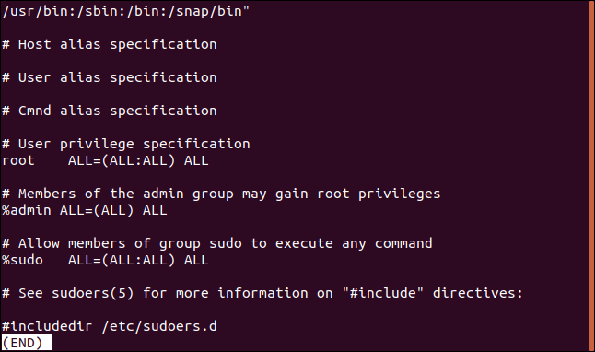
We can effectively filter out comment lines like this:
sudo grep -v "https://www.howtogeek.com/496056/how-to-use-the-grep-command-on-linux/#" /etc/sudoers
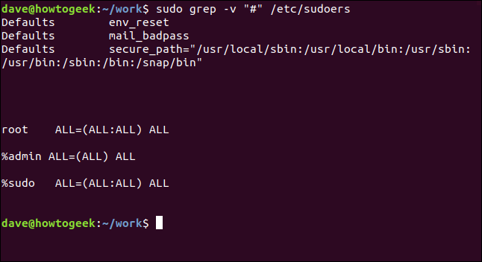
That's much easier to parse.

Show only matching text
There may be cases where you don't want to see the entire matched line, only the matching text. The -o(combined only) options do just that.
grep -o MemFree geek-1.log
The screen drops to only the text that matches the search term, rather than the entire line of matches.
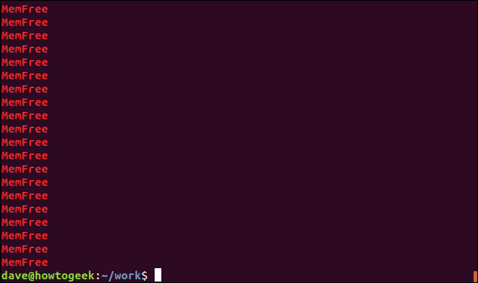

Count with grep
grep not only about text, it can also provide numeric information. We can do grepthe calculation for us in different ways. If we want to know how many times a search term appears in a file, we can use the -c(count) option.
grep -c average geek-1.log
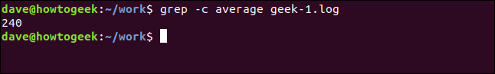
grep reports that the search term appears 240 times in this file.
You can make grepthe line number display for each matched line using the -n(line number) option.
grep -n Jan geek-1.log
6. Write a Linux pipeline that prints the eighth line of file z on standard output.
>>> The pipeline is as follows:
head –8 z | tail –1
The first part selects out the first eight lines of z and passes them to tail, which just writes the last one on the screen.
7. Why does Linux distinguish between standard output and standard error, when both default to the terminal?
>>> They are separate, so standard output can be redirected without affecting standard error. In a pipeline, standard output may go to another process, but standard error still writes on the terminal.
8. A user at a terminal types the following commands:
a | b | c & d | e | f &
After the shell has processed them, how many new processes are running?
>>> Run list process i Linux.

9. When the Linux shell starts up a process, it puts copies of its environment variables, such as HOME, on the process’ stack, so the process can find out what its home directory is. If this process should later fork, will the child automatically get these variables, too?
>>> Yes. fork will make exact copy of the parent process. As a result, the child will have same variables on the exact copy of the stack.

10. About how long does it take a traditional UNIX system to fork off a child process under the following conditions: text size = 100 KB, data size = 20 KB, stack size = 10 KB, task structure = 1 KB, user structure = 5 KB. The kernel trap and return takes 1 msec, and the machine can copy one 32-bit word every 50 nsec. Text segments are shared, but data and stack segments are not.
>>> Since text segments are shared, only 36 KB has to be copied. The machine can copy 80 bytes per microsec, so 36 KB takes 0.46 msec. Add another 1 msec for getting into and out of the kernel, and the whole thing takes roughly 1.46 msec.
11. As multimegabyte programs became more common, the time spent executing the fork system call and copying the data and stack segments of the calling process grew proportionally. When fork is executed in Linux, the parent’s address space is not copied, as traditional fork semantics would dictate. How does Linux prevent the child from doing something that would completely change the fork semantics?
>>> Linux relies on copy on write. It gives the child pointers to the parent’s address space, but marks the parent’s pages write-protected. When the child attempts to write into the parent’s address space, a fault occurs, and a copy of the parent’s page is created and allocated into the child’s address space.
12. Why are negative arguments too nice reserved exclusively for the superuser?
>>> When a function receives an argument of the correct type but an inappropriate value. Also, the situation should not be described by a more precise exception such as IndexError.

13. A non-real-time Linux process has priority levels from 100 to 139. What is the default static priority and how is the nice value used to change this?
>>> System priorities in Linux range from 0 to 139, with 0 to 99 for real-time and 100 to 139 for users. Nice value — Nice values are user-space variables that can be used to control a process's priority. The pleasant value range is -20 to +19,…

14. Does it make sense to take away a process’ memory when it enters zombie state? Why or why not?
>>> Yes. It cannot run any more, so the earlier its memory goes back on the free list, the better.
15. To what hardware concept is a signal closely related? Give two examples of how signals are used.
>>> Several examples of hardware used for signal processing were presented throughout the chapter to show the application of these principles in actual designs. We have also shown that the selection of the architecture and the technology is a crucial step to achieve the best performance of the signal processing hardware.
The hardware should be designed to meet the specifications of each particular application. Furthermore, it has been shown through several author works that an optimal hardware partitioning between analog and digital domains can lead to a significant improvement of the overall signal processor performance.

16. Why do you think the designers of Linux made it impossible for a process to send a signal to another process that is not in its process group?
>>> As already mentioned, a CPU can run in either User Mode or Kernel Mode. Actually, some CPUs can have more than two execution states. For instance, the 80 × 86 microprocessors have four different execution states. But all standard Unix kernels use only Kernel Mode and User Mode.
When a program is executed in User Mode, it cannot directly access the kernel data structures or the kernel programs. When an application executes in Kernel Mode, however, these restrictions no longer apply. Each CPU model provides special instructions to switch from User Mode to Kernel Mode and vice versa. A program usually executes in User Mode and switches to Kernel Mode only when requesting a service provided by the kernel. When the kernel has satisfied the program’s request, it puts the program back in User Mode.
Processes are dynamic entities that usually have a limited life span within the system. The task of creating, eliminating, and synchronizing the existing processes is delegated to a group of routines in the kernel.
The kernel itself is not a process but a process manager. The process/kernel model assumes that processes that require a kernel service use specific programming constructs called system calls . Each system call sets up the group of parameters that identifies the process request and then executes the hardware-dependent CPU instruction to switch from User Mode to Kernel Mode.
Besides user processes, Unix systems include a few privileged processes called kernel threads with the following characteristics:

17. A system call is usually implemented using a software interrupt (trap) instruction. Could an ordinary procedure call be used as well on the Pentium hardware? If so, under what conditions and how? If not, why not?
>>> A system call is expected to be significantly more expensive than a procedure call (provided that both perform very little actual computation). A system call involves the following actions, which do not occur during a simple procedure call, and thus entails a high overhead:
- A context switch
- A trap to a specific location in the interrupt vector
- Control passes to a service routine, which runs in 'monitor' mode
- The monitor determines what system call has occurred
- Monitor verifies that the parameters passed are correct and legal

18. In general, do you think daemons have higher or lower priority than interactive processes? Why?
>>> The daemons processes have higher preferential treatment than interactive cycles, since daemon process generally runs behind the scenes of a performing multiple tasks working framework and they are begun when the OS is started until shut down.

19. When a new process is forked off, it must be assigned a unique integer as its PID. Is it sufficient to have a counter in the kernel that is incremented on each process creation, with the counter used as the new PID? Discuss your answer.
>>> Under Unix, process IDs are usually allocated on a sequential basis, beginning at 0 and rising to a maximum value which varies from system to system. Once this limit is reached, allocation restarts at zero and again increases. However, for this and subsequent passes any PIDs still assigned to processes are skipped.
so it's really a very simple policy for "generation", just increment a counter, and "recycling", just wrap the number around at a max value and keep incrementing until you find a number that was assigned to a process that has finished and has been removed from the process table.
Some Unix implementations such as AIX use a policy that's less simple, see e.g.

20. In every process’ entry in the task structure, the PID of the parent is stored. Why?
>>> An existing (parent) process duplicates its own address space (fork) to create a new (child) process structure. Every new process is assigned a unique process ID (PID) for tracking and security. The PID and the parent's process ID (PPID) are elements of the new process environment. Any process may create a child process. Through the fork routine, a child process inherits security identities, previous and current file descriptors, port and resource privileges, environment variables, and program code. A child process may then exec its own program code. Normally, a parent process sleeps while the child process runs, setting a request (wait) to be signaled when the child completes. Upon exit, the child process has already closed or discarded its resources and environment. The only remaining resource, called a zombie, is an entry in the process table. The parent, signaled awake when the child exited, cleans the process table of the child's entry, thus freeing the last resource of the child process. The parent process then continues with its own program code execution. Every time you run a shell command, a program is run and a process is created for it. ... Linux is a multitasking operating system, which means that multiple programs can be running at the same time (processes are also known as tasks). Each process has the illusion that it is the only process on the computer.

21. The copy-on-write mechanism is used as an optimization in the fork system call, so that a copy of a page is created only when one of the processes (parent or child) tries to write on the page. Suppose a process p1 forks processes p2 and p3 in quick succession. Explain how a page sharing may be handled in this case.
>>> Copy on Write or simply COW is a resource management technique. One of its main use is in the implementation of the fork system call in which it shares the virtual memory(pages) of the OS.
In UNIX like OS, fork() system call creates a duplicate process of the parent process which is called as the child process.
The idea behind a copy-on-write is that when a parent process creates a child process then both of these processes initially will share the same pages in memory and these shared pages will be marked as copy-on-write which means that if any of these processes will try to modify the shared pages then only a copy of these pages will be created and the modifications will be done on the copy of pages by that process and thus not affecting the other process.
Suppose, there is a process P that creates a new process Q and then process P modifies page 3.
The below figures shows what happens before and after process P modifies page 3.

22. What combination of the sharing flags bits used by the Linux clone command corresponds to a conventional UNIX fork call? To creating a conventional UNIX thread?
>>> System call fork() is used to create processes. It takes no arguments and returns a process ID. The purpose of fork() is to create a new process, which becomes the child process of the caller. After a new child process is created, both processes will execute the next instruction following the fork() system call. Therefore, we have to distinguish the parent from the child. This can be done by testing the returned value of fork():
- If fork() returns a negative value, the creation of a child process was unsuccessful.
- fork() returns a zero to the newly created child process.
- fork() returns a positive value, the process ID of the child process, to the parent. The returned process ID is of type pid_t defined in sys/types.h. Normally, the process ID is an integer. Moreover, a process can use function getpid() to retrieve the process ID assigned to this process.

23. Two tasks A and B need to perform the same amount of work. However, task A has higher priority, and needs to be given more CPU time. Expain how will this be achieved in each of the Linux schedulers described in this chapter, the O(1) and the CFS scheduler.
>>> Since A has a higher priority than B, vruntime will move more slowly for A than B. If both A and B
are CPU-bound (that is they both use the CPU for as long as it is allocated to them), vruntime will
generally be smaller for A than B, and hence A will have a greater priority to run over B.
• In this situation, vruntime will be much smaller for A than B as (1) vruntime will move more
slowly for A than B due to priority differences, and (2) Awill require less CPU-time as it is I/O-bound.
• This situation is not as clear, and it is possible that B may end up running in favor of A as it will be
using the processor less than A and in fact its value of vruntime may in fact be less than the value
of vruntime for B.

24. Some UNIX systems are tickless, meaning they do not have periodic clock interrupts. Why is this done? Also, does ticklessness make sense on a computer (such as an embedded system) running only one process?
>>> After getting your degree, you apply for a job as director of a large university computer center
that has just put its ancient mainframe system out to pasture and switched over to a large LAN
server running UNIX. You get the job. Fifteen minutes after you start work, your assistant bursts
into your office screaming: ''
In the discussion of how URLs are processed by a browser, it was stated that connections are
made to port 80. Why?
Describe three features that make Java a better programming language than C to write secure
programs.

25. When booting Linux (or most other operating systems for that matter), the bootstrap loader in sector 0 of the disk first loads a boot program which then loads the operating system. Why is this extra step necessary? Surely it would be simpler to have the bootstrap loader in sector 0 just load the operating system directly.
>>> Booting step:
The boot program which is loaded from zero blocks can have a maximum size of 512 bytes Thus, loading of program doesn’t create complications. To load the operating system In the memory, the load and layout of the operating system must be known.
The file system may vary in different operating system. So, the expectation that a 512 byte program can solve the loading problem of all the operating system is a myth. Instead this, the zero block loaded fetches any other program loader from any specified location The location of that loader is anywhere on the disk. The fetched program can be large in size and specific to the system. Thus, the operating system is directly loaded in zero sectors.
Text Editor:
It used to put a text file in to the data file. It can also be used to read the content of the text rile. For an editor which contains 100 KB of program file text, the initialized data size is of 30 KB and the Block started by symbol (BSS) size is 50 KB The implementation of stack consumes 10 KB.
Due to BSS. the editor can start multiple instances simultaneously and share on the virtual addresses When three instances of the editor are started, each will need 80 KB, which is sum of the initial data and the BSS and use it for their data segment allocation. Also each instance will use 10 KB of the stack. A common shared space of 100 KB of the program text is also used. Hence the total spaced used by three instances of the editor in shared text is
80+80+80+10+10+10+100=370 KB

26. A certain editor has 100 KB of program text, 30 KB of initialized data, and 50 KB of BSS. The initial stack is 10 KB. Suppose that three copies of this editor are started simultaneously. How much physical memory is needed (a) if shared text is used, and (b) if it is not?
>>> It used to put a text file in to the data file. It can also be used to read the content of the text rile. For an editor which contains 100 KB of program file text, the initialized data size is of 30 KB and the Block started by symbol (BSS) size is 50 KB The implementation of stack consumes 10 KB.
Due to BSS. the editor can start multiple instances simultaneously and share on the virtual addresses When three instances of the editor are started, each will need 80 KB, which is sum of the initial data and the BSS and use it for their data segment allocation. Also each instance will use 10 KB of the stack. A common shared space of 100 KB of the program text is also used. Hence the total spaced used by three instances of the editor in shared text is
80+80+80+10+10+10+100=370 KB

27. Why are open-file-descriptor tables necessary in Linux?
>>> The application and the kernel need some common reference point for a particular open file. This could be anything. For what I hope are obvious reasons, the kernel would like this to be both opaque and secure. In current terminology, an open file needs a handle.
The kernel needs a way to ensure that the handle that it receives is valid. Having the handle be a pointer in kernel space is a valid approach, but the kernel must insure that it validates the pointer before it starts dereferencing it.
What would happen if the application could pass in an arbitrary handle and the kernel didn’t validate it? At the very least, you’d be accessing garbage memory and using it as a kernel data structure. A panic seems inevitable. At worst, this is a huge security hole.
One reasonable implementation would be to have a set of known open file pointers that hung off of the process context that was searched by file operations. The file descriptor table is a lightweight implementation of this concept. A heavier weight implementation that would be more scalable might be a splay tree or hash table.

28. In Linux, the data and stack segments are paged and swapped to a scratch copy kept on a special paging disk or partition, but the text segment uses the executable binary file instead. Why?
>>> The text segment cannot change, so it never has to be paged out. If its frames are needed, they can just be abandoned. The pages can always be retrieved from the file system. The data segment must not be paged back to the ex- ecutable file, because it is likely that it has changed since being brought in. Paging it back would ruin the executable file. The stack segment is not even present in the executable file.

29. Describe a way to use mmap and signals to construct an interprocess-communication mechanism.
>>> An independent process is not affected by the execution of other processes while a co-operating process can be affected by other executing processes. Though one can think that those processes, which are running independently, will execute very efficiently, in reality, there are many situations when co-operative nature can be utilized for increasing computational speed, convenience, and modularity. Inter-process communication (IPC) is a mechanism that allows processes to communicate with each other and synchronize their actions. The communication between these processes can be seen as a method of co-operation between them.

30. A file is mapped in using the following mmap system call:
mmap(65536, 32768, READ, FLAGS, fd, 0)
Pages are 8 KB. Which byte in the file is accessed by reading a byte at memory address 72,000?
>>> The desired memory address in the system call prepare with 65536, which is the file byte 0. So, the desired file byte at 72000 can be easily determine by finding the difference is as
72000—65536 = 6464
Thus, the desired file byte at 72000 is 6464

31. After the system call of the previous problem has been executed, the call munmap(65536, 8192)
is carried out. Does it succeed? If so, which bytes of the file remain mapped? If not, why does it fail?
>>> The system loader maintains a table of the functions that are used for each system call. The system call runs within the calling thread, but with more privilege because system calls run in the kernel protection domain. After the function implementing the system call has performed the requested action, control returns to the system call handler.

32. Can a page fault ever lead to the faulting process being terminated? If so, give an example. If not, why not?
>>> In computing, a page fault (sometimes called PF or hard fault)^{[a]} is an exception that the memory management unit (MMU) raises when a process accesses a memory page without proper preparations. Accessing the page requires a mapping to be added to the process's virtual address space. Besides, the actual page contents may need to be loaded from a backing store, such as a disk. The MMU detects the page fault, but the operating system's kernel handles the exception by making the required page accessible in the physical memory or denying an illegal memory access.

33. Is it possible that with the buddy system of memory management it ever occurs that two adjacent blocks of free memory of the same size coexist without being merged into one block? If so, explain how. If not, show that it is impossible.
>>> Static partition schemes suffer from the limitation of having the fixed number of active processes and the usage of space may also not be optimal. The buddy system is a memory allocation and management algorithm that manages memory in power of two increments. Assume the memory size is 2U, suppose a size of S is required.
- If 2U-1<S<=2U: Allocate the whole block
- Else: Recursively divide the block equally and test the condition at each time, when it satisfies, allocate the block and get out the loop.
System also keep the record of all the unallocated blocks each and can merge these different size blocks to make one big chunk.

34. It is stated in the text that a paging partition will perform better than a paging file. Why is this so?
>>> Paging to a partition allows the use of a raw device, without the overhead of using file-system data structures. To access block n, the operating system can calculate its disk position by just adding it to the starting block of the partition. There is no need to go through all the indirect blocks that would otherwise be needed.

35. Give two examples of the advantages of relative path names over absolute ones.
>>> Relative paths are also advantageous if one moves entire website from one domain to a different domain altogether. You do not have to change all local links. If we realise we want to change our domain to www.site.com 17 because of any other reasons but we want to leave the files intact, the picture1.jpg image will break.
36. The following locking calls are made by a collection of processes. For each call, tell what happens. If a process fails to get a lock, it blocks.
(a) A wants a shared lock on bytes 0 through 10.
(b) B wants an exclusive lock on bytes 20 through 30.
(c) C wants a shared lock on bytes 8 through 40.
(d) A wants a shared lock on bytes 25 through 35. (e) B wants an exclusive lock on byte 8.
>>> Serializability
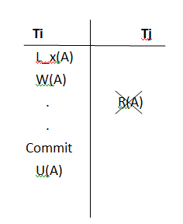

Serializability is guaranteed with this transaction. Because when Ti obtains a lock to write on A, it will not release the lock until all of the data has been written to A. As a result, no midway read is possible. Until Ti unlocks A, Tj is unable to read.
Avoid Cascading abort
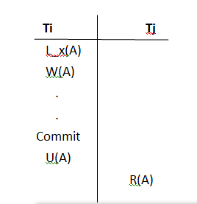
There are no aborts in a chain. It has a schedule that isn't cascading. because between Ti's transaction and Tj's transaction on A, Tj didn't accomplish anything on A. As a result, if something goes wrong for Ti and is rolled back, it has no bearing on Tj. Tj can only begin its transaction after Ti has committed and released the lock on A.
Recoverability
It is possible to get it back. Tj didn't even begin reading before Ti committed, so Tj does not begin its transaction until Ti has committed and the lock on A has been released. As a result, if something goes wrong with Ti, Tj will not intervene. As a result, there's no way to get your money back. It is possible to recover every cascadeless schedule.
Conflict Serializability
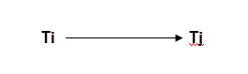

It is serializable when it comes to conflict. In between Ti and Tj, there is no cycle. Tj begins only after Ti, and Ti ceases to function after Tj has begun.

37. Consider the locked file of Fig. 10-26(c). Suppose that a process tries to lock bytes 10 and 11 and blocks. Then, before C releases its lock, yet another process tries to lock bytes 10 and 11, and also blocks. What kinds of problems are introduced into the semantics by this situation? Propose and defend two solutions.
>>> The method which implements the DFS locking of records and files involves the following steps. If the file is a local file, then the UNIX operating system standard file locking is used. However, if a remote file is to be locked, the UNIX operating system LOCKF and FCNTL system calls are intercepted and an remote process call (RPC) DFS₋₋ LOCK₋₋ CONTROL is executed. The server node receives the remote process call and carries out the lock request.

38. Explain under what situations a process may request a shared lock or an exclusive lock. What problem may a process requesting an exclusive lock suffer from?
>>> Shared Lock:
Shared lock can be acquired by unlimited number of processes at the same time. To acquire a shared lock, a process must wait until no processes hold any exclusive locks.
Shared locks are held on data being read under the pessimistic concurrency model. While a shared lock is being held other transactions can read but can't modify locked data. After the locked data has been read the shared lock is released.
If lock requests for the same entity are queued, then once a shared lock is granted, any queued shared locks may also be granted. If an exclusive lock is found next on the queue, it must wait until all shared locks have been released.
Exclusive lock:
An exclusive lock can only be acquired by one process, and cannot coexist with a shared lock.
To acquire an exclusive lock, a process must wait until no processes hold either kind of lock.
As the names implies exclusive locks are held by single entity.Usually the purpose of exclusive locks are held during writing to the record.At a time only one entity will get this lock and the other will have to wait till the completion of work. Exclusive locks cannot be obtained when a record is already locked (exclusively or shared) by another entity.
Exclusive locks are used to lock data being modified by one transaction thus preventing modifications by other concurrent transactions. You can read data held by exclusive lock.Because DML statements first need to read the data they want to modify you'll always find Exclusive locks accompanied by shared locks on that same data.
What problem may a process requesting an exclusive lock suffer from?
At a time only one entity will held the lock during writing to the record.Then other entity which requires exclusive lock have to wait until the previous entity which acquired exclusive lock completes it work.If it takes more time to complete its work then other entities will have to wait for longer time.some times it may lead to dead lock.so care must be taken to ensure that the lock must be held for shortest time possible.Not hold the lock across system or function calls where the entity is no longer running on the processor - this can lead to deadlock.

39. If a Linux file has protection mode 755 (octal), what can the owner, the owner’s group, and everyone else do to the file?
>>> The owners of the files, directories and processes will be assigned to these three types of users: regular, system, or root. Before we try to explore what permissions can be assigned to these three types of users, let’s try to understand the types of permission that are available in Linux.

40. Some tape drives have numbered blocks and the ability to overwrite a particular block in place without disturbing the blocks in front of or behind it. Could such a device hold a mounted Linux file system?
>>> A tape drive is a device that stores computer data on magnetic tape, especially for backup and archiving purposes. Like an ordinary tape recorder, a tape drive records data on a loop of flexible celluloidlike material that can be read and also erased.
Tape drives work either by using a traditional helical scan where the recording and playback heads touch the tape, or linear tape technology, where the heads never actually touch the tape. Drives can be rewinding, where the device issues a rewind command at the end of a session, or non-rewinding.

41. In Fig. 10-24, both Fred and Lisa have access to the file x in their respective directories after linking. Is this access completely symmetrical in the sense that anything one of them can do with it the other one can, too?
>>> Sequential access is a term describing a group of elements (such as data in a memory array or a disk file or on magnetic tape data storage) being accessed in a predetermined, ordered sequence. It is the opposite of random access, the ability to access an arbitrary element of a sequence as easily and efficiently as any other at any time.
Sequential access is sometimes the only way of accessing the data, for example if it is on a tape. It may also be the access method of choice, for example if all that is wanted is to process a sequence of data elements in order.

42. As we have seen, absolute path names are looked up starting at the root directory and relative path names are looked up starting at the working directory. Suggest an efficient way to implement both kinds of searches.
>>> An absolute path is defined as specifying the location of a file or directory from the root directory(/). In other words,we can say that an absolute path is a complete path from start of actual file system from / directory.

43. When the file /usr/ast/work/f is opened, several disk accesses are needed to read i-node and directory blocks. Calculate the number of disk accesses required under the assumption that the i-node for the root directory is always in memory, and all directories are one block long.
>>> You need a suitable software like User Database to open a USR file. Without proper software you will receive a Windows message "How do you want to open this file?" or "Windows cannot open this file" or a similar Mac/iPhone/Android alert. If you cannot open your USR file correctly, try to right-click or long-press the file. Then click "Open with" and choose an application. You can also display a USR file directly in the browser. Just drag the file onto this browser window and drop it.

44. A Linux i-node has 12 disk addresses for data blocks, as well as the addresses of single, double, and triple indirect blocks. If each of these holds 256 disk addresses, what is the size of the largest file that can be handled, assuming that a disk block is 1 KB?
>>>
A Linux i-Node has 12 disk addresses for data blocks,
as well as the addresses of single, double and triple
indirect blocks.
If each of these holds 256 disk addresses what is the
size of the largest file that can be handled, assuming
that a disk block is 1KB?
In Linux, i node data structure represents filesystem object like a directory or a file
Each disk block = 1024 Bytes = 1 KB
256 * 12 = 3072 Bytes = 3 KB
3072 / 1024 = 3 blocks each
i node means a single pointer to a block of data of size 1 KB in our case
plus 1 pointer for the indirect block
we have single, double and triple indirect blocks
hence indirect block will occupy 2 pointers to dat blocks
space size requirements for the directory will be that of a regular file with zero pairs or more than zero pairs of integer numbers.
The pair is made up of file name and file number
index size = whether 2 or 4 bytes
Number of bits used for each entry
The limit of the file size is determined by many factors for a specific file system
on a GFS2 file system, with RHEL 6, the maximum size can be 100 TiB
where Tib is a Tebibyte which is equal to 2 raised to the power of 40

45. When an i-node is read in from the disk during the process of opening a file, it is put into an i-node table in memory. This table has some fields that are not present on the disk. One of them is a counter that keeps track of the number of times the i-node has been opened. Why is this field needed?
>>> The process table:
Managing processes is one of the kernel's biggest responsibilities. It decides which process actually gets to run on the CPU (or CPUs) at any point in time. The kernel keeps a data structure (in kernel space) to track information about processes: the process table. Each process has an entry in this table (entries are called process control blocks that include all sorts of information. The processes ID (pid) is one piece of info, we'll look at some others shortly. You can actually look at all this process table information by examining files (at least they look like files) in the /proc directory. Try man -s4 proc for more information. And, of course, the ps command gives some info as well. Think of the kernel as a business and the processes as customers. The process table is like the records business keep on clients.
File I/O:
When a process opens a file and reads or writes, we can identify several entities involved:
- The actual file on the harddrive,
- the kernel's record that stores in memory (i.e. RAM) basic file info - like permissions, location on the harddrive, etc,
- the kernel's record relating to that processes's connection to the file (after all, many processes may be reading fromt he file at the same time, or maybe the same process has several different connections reading from the file simultaneously, but at different locations), and
- the number that the process uses to tell the kernel which file-connection it's trying to read-from/write-to.
The basic system calls for dealing with file I/O are open, which requests that a connection to a file be made; close, which requests that a connection to a file be closed; read, which requests that some bytes be read from a file via a specified connection; and write, which requests that some bytes be written to a file via a specified connection

46. On multi-CPU platforms, Linux maintains a runqueue for each CPU. Is this a good idea? Explain your answer?
>>> By maintaining per-CPU runqueues, scheduling decisions can be made locally, without executing expensive synchronization mechanisms to always access, and update, a shared runqueue. Also, it is more likely that all relevant memory pages will still be in the cache1 if we schedule a thread on the same CPU where it already executed.
47. The concept of loadable modules is useful in that new device drivers may be loaded in the kernel while the system is running. Provide two disadvantages of this concept.
>>> One disadvantage is security, as a loadable module may contain bugs and exploits. Another disadvantage is that the kernel virtual address space may become fragmented as more and more modules are loaded.
48. Pdflush threads can be awakened periodically to write back to disk very old pages— older than 30 sec. Why is this necessary?
>>> The kernel page cache contains in-memory copies of data blocks belonging to files kept in persistent storage. Pages which are written to by a processor, but not yet written to disk, are accumulated in cache and are known as "dirty" pages. The amount of dirty memory is listed in /proc/meminfo. Pages in the cache are flushed to disk after an interval of 30 seconds. Pdflush is a set of kernel threads which are responsible for writing the dirty pages to disk, either explicitly in response to a sync() call, or implicitly in cases when the page cache runs out of pages, if the pages have been in memory for too long, or there are too many dirty pages in the page cache (as specified by /proc/sys/vm/dirty_ratio).
At a given point of time, there are between two and eight pdflush threads running in the system. The number of pdflush threads is determined by the load on the page cache; new pdflush threads are spawned if none of the existing pdflush threads have been idle for more than one second, and there is more work in the pdflush work queue. On the other hand, if the last active pdflush thread has been asleep for more than one second, one thread is terminated. Termination of threads happens until only a minimum number of pdflush threads remain. The current number of running pdflush threads is reflected by /proc/sys/vm/nr_pdflush_threads.

49. After a system crash and reboot, a recovery program is usually run. Suppose this program discovers that the link count in a disk i-node is 2, but only one directory entry references the i-node. Can it fix the problem, and if so, how?
>>> The primary objective of this article is to help you recover lost data, right at home. It’s possible to recover files after the computer crashed if you act swiftly. The listed recovery methods cover a wide range of data loss scenarios, ranging from operating system failure, to a hard drive crash.

50. Make an educated guess as to which Linux system call is the fastest.
>>> Config.guess might need to compile and run C code, hence it needs a compiler for the 'build' machine: use the environment variable 'CC_FOR_BUILD' to specify the compiler for the build machine. If 'CC_FOR_BUILD' is not specified, 'CC' will be used. Be sure to specify 'CC_FOR_BUILD' is 'CC' is a cross-compiler to the 'host' machine.
CC_FOR_BUILD a native C compiler, defaults to 'cc'
CC a native C compiler, the previous variable is preferred

51. Is it possible to unlink a file that has never been linked? What happens?
>>> In Unix all normal files are Hardlinks. Hardlinks in a Unix (and most (all?)) filesystems are references to what's called an inode. The inode has a reference counter, when you have one "link" to the file (which is the normal modus operandi) the counter is 1. When you create a second, third, fourth, etc link, the counter is incremented (increased) each time by one. When you delete (rm) a link the counter is decremented (reduced) by one. If the link counter reaches 0 the filesystem removes the inode and marks the space as available for use.
In short, as long as you do not delete the last link the file will remain.
Edit: The file will remain even if the last link is removed. This is one of the ways to ensure security of data contained in a file is not accessible to any other process. Removing the data from the filesystem completely is done only if the data has 0 links to it as given in its metadata and is not being used by any process.
This IMHO is by far the easiest way to understand hard-links (and its difference from softlinks).

52. Based on the information presented in this chapter, if a Linux ext2 file system were to be put on a 1.44-MB floppy disk, what is the maximum amount of user file data that could be stored on the disk? Assume that disk blocks are 1 KB.
>>> The FAT file system offers reasonable performance, even in very light-weight implementations. It is therefore widely adopted and supported by virtually all existing operating systems for personal computers as well as some home computers and a multitude of embedded systems. This makes it a useful format for solid-state memory cards and a convenient way to share data between operating systems.
FAT file systems are the default file system for removable media (with the exception of CDs and DVDs) and as such are commonly found on floppy disks, super-floppies, memory and flash memory cards or USB flash drives and are supported by most portable devices such as PDAs, digital cameras, camcorders, media players, or mobile phones. While FAT12 is omnipresent on floppy disks, FAT16 and FAT32 are typically found on the larger media.
FAT was also commonly used on hard disks throughout the DOS and Windows 9x eras, but its use on hard drives has declined since the introduction of Windows XP, which primarily uses the newer NTFS. FAT is still used in hard drives expected to be used by multiple operating systems, such as in shared Windows, Linux and DOS environments.
Due to the widespread use of FAT-formatted media, many operating systems provide support for FAT through official or third-party file system handlers. For example, Linux, FreeBSD, BeOS and JNode provide inbuilt support for FAT, even though they also support more sophisticated file systems such as ext4 or btrfs. Mac OS 9 and Mac OS X support FAT file systems on volumes other than the boot disk. AmigaOS supports FAT through the CrossDOS package.
For many purposes, the NTFS file system is superior to FAT in terms of features and reliability; its main drawbacks are the size overhead for small volumes and the very limited support by anything other than the NT-based versions of Windows, since the exact specification is a trade secret of Microsoft. The availability of NTFS-3G since mid-2006 has led to much improved NTFS support in Unix-like operating systems, considerably alleviating this concern. It is still not possible to use NTFS in DOS-like operating systems without third-party drivers, which in turn makes it difficult to use a DOS floppy for recovery purposes. Microsoft provided a recovery console to work around this issue, but for security reasons it severely limited what could be done through the Recovery Console by default. The movement of recovery utilities to boot CDs based on BartPE, Linux (with NTFS-3G), or WinPE is finally eroding this drawback.
FAT has a long history (over three decades) of usage on desktops and portable computers, and it is frequently used in embedded solutions. As such, it continues to be the most widespread file system worldwide.
It is also utilized internally for the EFI system partition (partition type 0xEF) in the boot stage of EFI-compliant computers.

53. In view of all the trouble that students can cause if they get to be superuser, why does this concept exist in the first place?
>>> You need to analyze a situation fully before you can move on to look at factors that contributed to the problem. To maximize the effectiveness of your RCA, get together everyone – experts and front line staff – who understands the situation. People who are most familiar with the problem can help lead you to a better understanding of the issues.

54. A professor shares files with his students by placing them in a publicly accessible directory on the Computer Science department’s Linux system. One day he realizes that a file placed there the previous day was left world-writable. He changes the permissions and verifies that the file is identical to his master copy. The next day he finds that the file has been changed. How could this have happened and how could it have been prevented?
>>> University students in courses from engineering to physics are having to be taught what files and folders are, The Verge reports
(opens in new tab)
, because that's not how they've grown up using computers. Whenever they need a file, they just search for it.
"I tend to think an item lives in a particular folder. It lives in one place, and I have to go to that folder to find it," astrophysicist Catherine Garland said. "They see it like one bucket, and everything's in the bucket."
Strange as it may seem to older generations of computer users who grew up maintaining an elaborate collection of nested subfolders, thanks to powerful search functions now being the default in operating systems, as well as the way phones and tablets obfuscate their file structure, and cloud storage, high school graduates don't see their hard drives the same way.

55. Linux supports a system call fsuid. Unlike setuid, which grants the user all the rights of the effective id associated with a program he is running, fsuid grants the user who is CHAP. 10 PROBLEMS
running the program special rights only with respect to access to files. Why is this feature useful?
>>> If, say, superuser rights are given to another user with the fsuid system call, that user can access superuser files, but will not be able to send signals, kill processes, or perform other operations which require superuser privileges.
56. On a Linux system, go to /proc/#### directory, where #### is a decimal number corresponding to a process currently running in the system. Answer the following along with an explanation:
(a) What is the size of most of the files in this directory?
(b) What are the time and date settings of most of the files?
(c) What type of access right is provided to the users for accessing the files?
>>> Under Linux, all data are stored as files. Most users are familiar with the two primary types of files: text and binary. But the /proc/ directory contains another type of file called a virtual file. It is for this reason that /proc/ is often referred to as a virtual file system.
These virtual files have unique qualities. Most of them are listed as zero bytes in size and yet when one is viewed, it can contain a large amount of information. In addition, most of the time and date settings on virtual files reflect the current time and date, indicative of the fact they are constantly updated.
Virtual files such as /proc/interrupts, /proc/meminfo, /proc/mounts, and /proc/partitions provide an up-to-the-moment glimpse of the system's hardware. Others, like the /proc/filesystems file and the /proc/sys/ directory provide system configuration information and interfaces.
For organizational purposes, files containing information on a similar topic are grouped into virtual directories and sub-directories. For instance, /proc/ide/ contains information for all physical IDE devices. Likewise, process directories contain information about each running process on the system.

57. If you are writing an Android activity to display a Web page in a browser, how would you implement its activity-state saving to minimize the amount of saved state without losing anything important?
>>> Depending upon the action a user takes, they either expect that activity state to be cleared or the state to be preserved. In some cases the system automatically does what is expected by the user. In other cases the system does the opposite of what the user expects.

User-initiated UI state dismissal
The user expects that when they start an activity, the transient UI state of that activity will remain the same until the user completely dismisses the activity. The user can completely dismiss an activity by:
- pressing the back button
- swiping the activity off of the Overview (Recents) screen
- navigating up from the activity
- killing the app from Settings screen
- completing some sort of "finishing" action (which is backed by Activity.finish())
The user's assumption in these complete dismissal cases is that they have permanently navigated away from the activity, and if they re-open the activity they expect the activity to start from a clean state. The underlying system behavior for these dismissal scenarios matches the user expectation - the activity instance will get destroyed and removed from memory, along with any state stored in it and any saved instance state record associated with the activity.
There are some exceptions to this rule about complete dismissal -- for example a user might expect a browser to take them to the exact webpage they were looking at before they exited the browser using the back button.

58. If you are writing networking code on Android that uses a socket to download a file, what should you consider doing that is different than on a standard Linux system?
>>> This class implements client sockets (also called just "sockets"). A socket is an endpoint for communication between two machines.
The actual work of the socket is performed by an instance of the SocketImpl class. An application, by changing the socket factory that creates the socket implementation, can configure itself to create sockets appropriate to the local firewall.

59. If you are designing something like Android’s zygote process for a system that will have multiple threads running in each process forked from it, would you prefer to start those threads in zygote or after the fork?
>>> Basically the Zygote processes are the core of the Android for any system and also it contained multiple threads during each processes. which starts up during initialy.
IN this Activity service manager create a new processes by using startprocess locked() method which sends some arguments to zygote process .
Zygote forks itelf and calls ZygoteInit.main() which then give an activity threads object and return a processes id every time for newly upcoming process.
Every process get one by default threads every time whcih gives number of threads in whole system. those threads should perform after a fork . the main thread has a looper which handles the messages from message queue.and its calls looper.loop() in every iteration.

60. Imagine you use Android’s Binder IPC to send an object to another process. You later receive an object from a call into your process, and find that what you have received is the same object as previously sent. What can you assume or not assume about the caller in your process?
>>> Most BIOS calls use the AH register as a "function select" parameter, and use the AL register as a data parameter. The function selected by AH depends on the interrupt called. Some BIOS calls require a single 16-bit parameter in AX, or do not accept parameters at all, and are simply called by the interrupt. Some have even more parameters, that are passed in other registers.
The registers used for BIOS calls are fixed and cannot be interchanged with other registers.

61. Consider an Android system that, immediately after starting, follows these steps:
1. The home (or launcher) application is started.
2. The email application starts syncing its mailbox in the background.
3. The user launches a camera application.
4. The user launches a Web browser application.
The web page the user is now viewing in the browser application requires inceasingly more RAM, until it needs everything it can get. What happens?
>>> Activity A is run on application start. It is supposed to do a asyntask in the background automatically to login to a server based on imei, also starting a service. If login is failed activity A will have a refresh button for user to rerun the asyn task. After login is done, the activity is being finished by finish() and flow to B then to C.
There is 2 problem faced.
- At any point of time if the user were to re-run the application via app menu, activity A will run again which result in unnecessary login and running of some background service.
- At activity C when i press Back it returns to B and then back which returns to main menu, which is correct. however when i press Home button and select back the app the application reruns activity A again.

62. Write a minimal shell that allows simple commands to be started. It should also allow them to be started in the background.
>>> So we’ve taken care of how the program should start up. Now, for the basic program logic: what does the shell do during its loop? Well, a simple way to handle commands is with three steps:
- Read: Read the command from standard input.
- Parse: Separate the command string into a program and arguments.
- Execute: Run the parsed command.

63. Using assembly language and BIOS calls, write a program that boots itself from a floppy disk on a Pentium-class computer. The program should use BIOS calls to read the keyboard and echo the characters typed, just to demonstrate that it is running.
>>> I have not explained why a boot loader cannot be written in other languages like assembly and the drawbacks in terms of writing a boot loader in one language when compared to another. As this is an introductory learning article on how to write boot code I don't want to bother you much about more advanced topics like speed, writing smaller code, etc.

64. Write a dumb terminal program to connect two Linux computers via the serial ports. Use the POSIX terminal management calls to configure the ports.
>>> The agetty program will auto-detect any parity set inside the terminal. Except it will not work if you use 8-bit data bytes with 1-bit parity. See Agetty's parity with 8-bit data bytes. If you use stty to set parity, agetty will automatically unset it since it wants the parity bit to come thru as if it was a data bit. This is because it needs to get the last bit (possibly a parity bit) as you type your login-name so that it can auto-detect parity. Thus if you use parity, enable it only at the terminals and let agetty auto-detect it and set it at the computer. If your terminal supports received parity, the login prompt will look garbled until you type something so that getty can detect the parity. The garbled prompt will deter visitors, etc. from trying to login. That could be just what you want.
There is sometimes a problem with auto detection of parity. This happens because after you first type your login name, agetty uses the login program to finish logging you in. If the first login attempt fails, login runs again to handle all future attempts at logging in (including the type-in of your login-name). The problem is that only agetty can detect parity while the login program doesn't detect parity. So if for some reason you wind up in the login program and the correct parity hasn't yet been detected, you're in trouble since the login program can't detect the parity. With wrong parity, the login program can't correctly read what you type and you can't log in. If your terminal supports received parity, you will continue to see a garbled screen.
One may get into this "login loop" in various ways. Suppose you only type a single letter or two for your login name and then hit return. If these letters are not sufficient for parity detection, then login runs before parity has been detected. Sometimes this problem happens if you don't have the terminal on and connected when agetty first starts up. If you get stuck in this "login" loop a solution is to just wait about a minute until agetty runs again due to "timeout".

65. Write a client-server application which, on request, transfers a large file via sockets. Reimplement the same application using shared memory. Which version do you expect to perform better? Why? Conduct performance measurements with the code you have written and using different file sizes. What are your observations? What do you think happens inside the Linux kernel which results in this behavior?
>>> We keep the number of threads as low as possible. Don't forget to check not only your server threads but also other parts of your application: queue/topic consumer, DB driver settings, logging settings (with asynchronous micro-batching). Always make a thread dump to see what threads are created in your application and how many (don't forget to make it under the load otherwise your thread-pools won't be fully initialized, a lot of them create threads lazily). I always name my custom threads from thread-pool (it's much easier to find a victim and debug your code).

66.
Implement a basic user-level threads library to run on top of Linux. The library API should contain function calls like mythreads init, mythreads create, mythreads join, mythreads exit, mythreads yield, mythreads self, and perhaps a few others. Next, implement these synchronization variables to enable safe concurrent operations: mythreads mutex init, mythreads mutex lock, mythreads mutex unlock. Before starting, clearly define the API and specify the semantics of each of the calls. Next implement the user-level library with a simple, round-robin preemptive scheduler. You will also need to write one or more multithreaded applications, which use your library, in order to test it. Finally, replace the simple scheduling mechanism with another one which behaves like the Linux 2.6 O(1) scheduler described in this chapter. Compare the performance your application(s) receive when using each of the schedulers.
>>> A thread library provides programmers with an API for creating and managing threads. Support for threads must be provided either at the user level or by the kernel.
- Kernel level threads are supported and managed directly by the operating system.
- User level threads are supported above the kernel in user space and are managed without kernel support.
Kernel level threads are supported and managed directly by the operating system.
- The kernel knows about and manages all threads.
- One process control block (PCP) per process.
- One thread control block (TCB) per thread in the system.
- Provide system calls to create and manage threads from user space.

67. Write a shell script that displays some important system information such as what processes you are running, your home directory and current directory, processor type, current CPU utilization, etc.
>>> echo "enter the directory name"
read dir
if [ -d $dir ]
then
cd $dir
ls > f
exec < f
while read line
do
if [ -f $line ]
then
if [ -r $line -a -w $line -a -x $line ]
then
echo "$line has all permissions"
else
echo "files not having all permissions"
fi
fi
done
fi

Output:
student@ubuntu:~$sh prg3.sh
enter the directory name
dir1
ff has all permissions
files not having permissions
---The End---

